**Usage Instructions(Red Text Represents the Content of Assignment 2)**

1. **Setting Up the Application**
   1. **Microsoft SQL Server Setup**
2. Ensure that Microsoft SQL Server has been installed and running on your computer.
3. Create a database and execute the scripts provided to generate relative tables and relationships. Or use the backup file provided to restore a database with some test data which could help familiarize the structure of the application.
   1. **Microsoft Access Setup**
4. Ensure that Microsoft Access has been installed and running on your computer.
5. Ensure that all tables from the SQL Server database are linked correctly in Microsoft Access.
6. **Using the Application**
   1. **Client Management**
7. Click the ‘Client_Management_Navigation’ form and open it,you will have the option to the informations of the Client Management system. (image 1.1)
8. Click the ‘Client’ form and open it, then input the client information, including client_id, name, gender, phone number, email address, and address. Then click the button ‘Add’, and the data of the form will be added to the database. (image 1.2)
9. Click the button ‘Find’, and we can input the ‘Client ID’ to find the related information, we can edit it and click ‘Save’ to update. (image 1.3)
10. Click the button ‘Delete’ to delete data.
11. If the client belongs to a guitar owner, more information should be completed in the form ‘Owner’. The step is the same as the ‘Client’ form. (image 1.4)
12. Report: click the report ‘Owner or ‘Client’, and all the owner and client information will be displayed. (image 1.5)

(image 1.1)

(image 1.2)

(image 1.3)

(image 1.4)

(image 1.5)

* 1. **Guitar Management**

1. Click the ‘Guitar_Management_Navigation’ form and open it,you will have the option to the informations of the Guitar Management system. (image 2.1)
2. Click the form ‘GuitarForm_PhotoForm’, open a new form, and input information. The filed ‘Owner ID’ is required. Under the form about guitar, photo information could be input as well. ‘Guitar ID’ is required which must be associated with a ‘Guitar ID’ in the table or form of the guitar. (image 2.2)
3. Edit, update, and delete operation, please look at the ‘Client Management’ which is the same as this.
4. Report: click the report ‘Guitar’ or ‘Photo’, and all the guitar and photo information will be displayed. (image 2.3, 2.4)

(image 2.1)

(image 2.2)

(image 2.3)

(image 2.4)

* 1. **Employee Management**

1. Click the ‘Employee_Management_Navigation’ form and open it,you will have the option to the informations of the Employee Management system. (image 3.1)
2. Click the form ‘Department’ and add the information of departments. (image 3.2)
3. Click the form ‘Employee’ and add the information of employees. Please pay attention, the ‘Department ID’ is required which is associated with the ‘Department ID’ in the table or form of ‘Department’. (image 3.3)
4. Edit, update, and delete operation, please look at the ‘Client Management’ which is the same as this.
5. Report: click the report ‘Department’ or ‘Employee’, and all the department and employee information will be displayed. (image 3.4, 3.5)
   * 1. Functional Descriptions for V_employee View and INSTEAD OF Triggers
        1. **Modification of Phone Numbers in V_employee View**:

The *V_employee* view allows users to update employee phone numbers directly within the view. To ensure that these updates do not interfere with the historical data, an *INSTEAD OF* trigger has been implemented. This trigger captures the phone number changes and stores the old and new values along with timestamps in the *T_EMPLOYEE_PHONE_HISTORY* table. This setup maintains a comprehensive record of changes, allowing for easy tracking and auditing of phone number modifications. (image 3.6 before modification),(image 3.7 after modification)

(image 3.6 before modification)

(image 3.7 after modification)

**2.3.1.2 Viewing Historical Data**:

A new feature has been added to the application where users can view the historical data for each field, such as phone numbers. This is done through a pop-up form that displays the history specific to the selected field. For instance, when a user clicks on the “View Phone Number History” button, a form appears showing a detailed history of all phone number changes, including start and end timestamps. This functionality is particularly useful for auditing purposes and provides transparency regarding any modifications made over time.

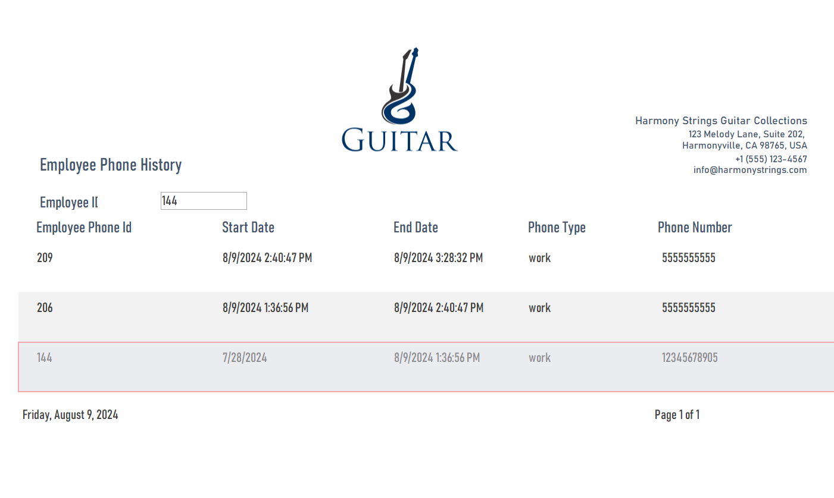

**Modification of Associated Tables:**

When updating phone numbers in the V_employee view, the corresponding records in the associated tables EMPLOYEE_PHONE, T_PHONE, and T_EMPLOYEE are also automatically updated. This is accomplished through a set of INSTEAD OF triggers to ensure that any updates, inserts, or deletes made in the view are synchronized with these associated tables.

Specifically:

**Modification of EMPLOYEE_PHONE Table:**

The trigger captures any changes to phone numbers and updates the data in the EMPLOYEE_PHONE table accordingly, ensuring that the phone numbers in this table remain consistent with the data in the V_employee view.(image3.8)

.(image3.8)

**Modification of T_PHONE Table:**

When a phone number is modified in the view, the trigger also updates the relevant records in the T_PHONE table to ensure the accuracy and completeness of the phone numbers. (image3.9)

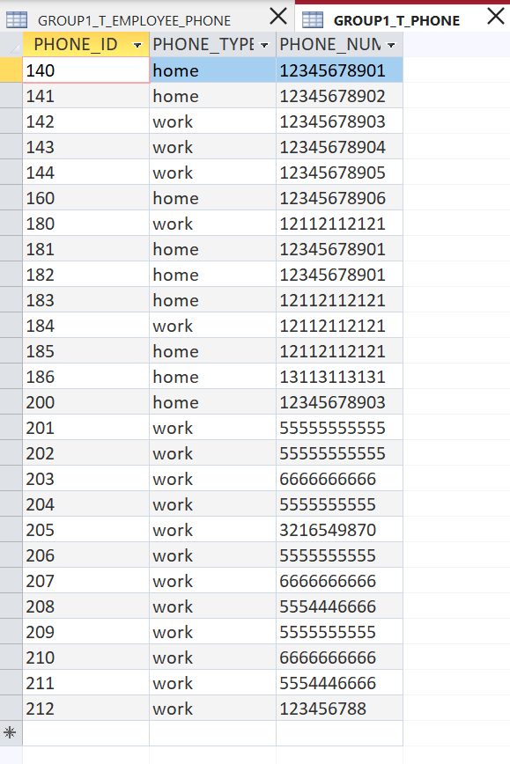

(image3.9)

**Modification of T_EMPLOYEE Table:**

Any modifications to employee information (such as changes to phone numbers) made in the V_employee view are reflected in the T_EMPLOYEE table via the trigger, maintaining synchronization and consistency of all related data.(image 4.0)

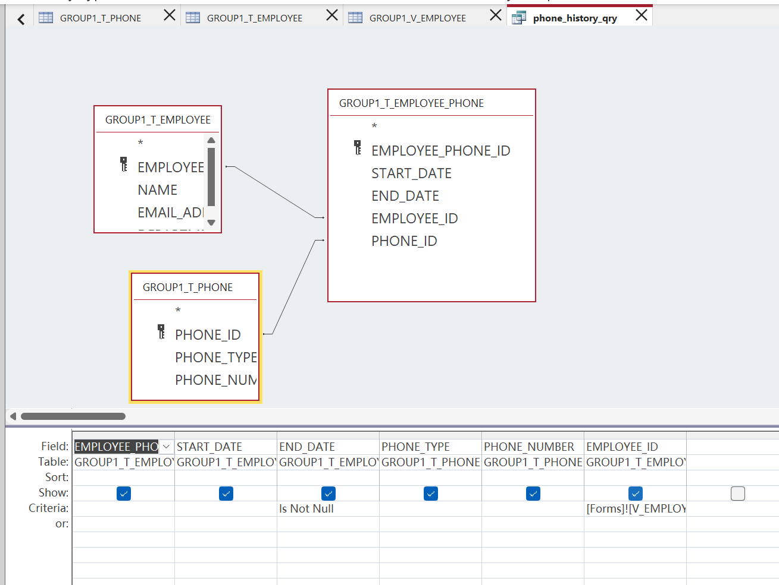

(image 4.0)

**2.3.1.2 Viewing Historical Data**:

2.3.1.2 A new feature has been added to the application where users can view the historical data for each field, such as phone numbers. This is done through a pop-up form that displays the history specific to the selected field. For instance, when a user clicks on the “View Phone Number History” button, a form appears showing a detailed history of all phone number changes, including start and end timestamps. This functionality is particularly useful for auditing purposes and provides transparency regarding any modifications made over time.

(image 3.1)

(image 3.2)

(image 3.3)

(image 3.4)

(image 3.5)

* 1. **Maintenance Management**

1. Click the ‘Maintenance_Management_Navigation’ form and open it,you will have the option to the informations of the Maintenance Management system. (image 4.1)
2. Click the form ‘Maintenance’ and add the information of one maintenance. (image 4.2)
3. The maintenance should be associated with employees. Therefore, open ‘Employee_maintenance_relation’ and add associated information. All the fields are required and ‘Employee ID’ and ‘Maintenance ID’ must be associated in the form or table of employee and maintenance respectively. (image 4.3)
4. Edit, update, and delete operation, please look at the ‘Client Management’ which is the same as this.
5. Report: click the report ‘Maintenance’ or ‘Employee_maintenance_relation’, and all the maintenance and relation information will be displayed. (image 4.4, 4.5)

(image 4.1)

(image 4.2)

(image 4.3)

(image 4.4)

(image 4.5)